Rotation

It is moving of an object about an angle. Movement can be anticlockwise or clockwise. 3D rotation is complex as compared to the 2D rotation. For 2D we describe the angle of rotation, but for a 3D angle of rotation and axis of rotation are required. The axis can be either x or y or z.

**Following figures shows rotation about x, y, z- axis**

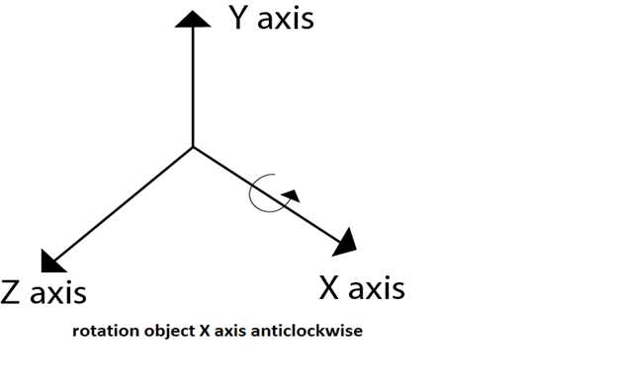

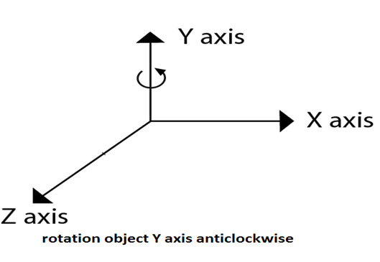  
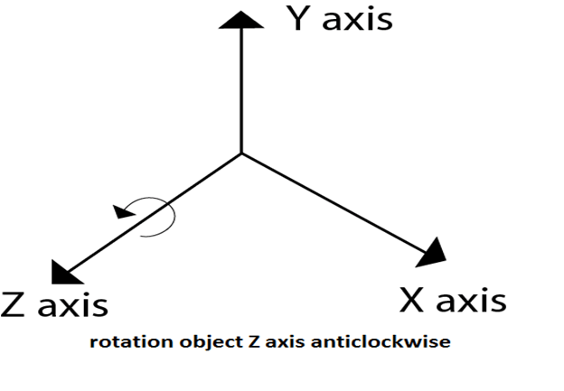  
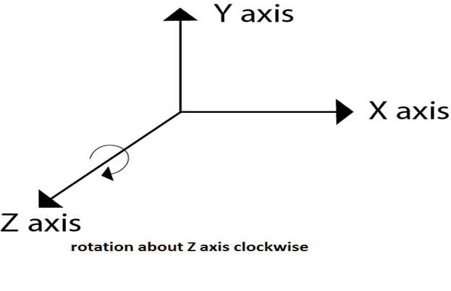  
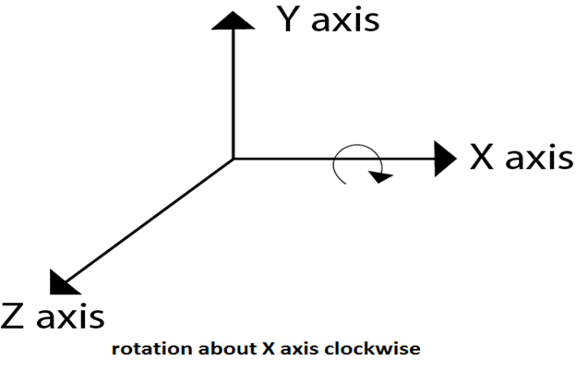

Following figure show rotation of the object about the Y axis

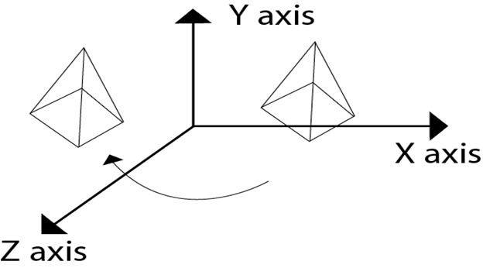

Following figure show rotation of the object about the Z axis

